

INFS702_2018_02VN

IT SERVICE MANAGEMENT VN 2018

IT Service Management Strategy and Implementation Plan

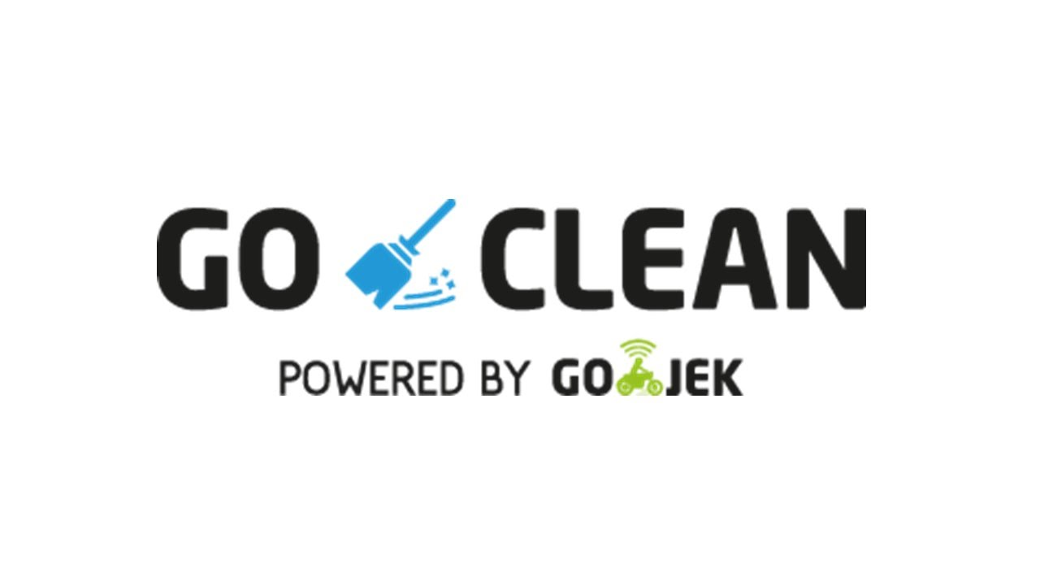

**Team members:**

Tran Tuan Khoi - 17984035

Nguyen Hoang Dang - 17983615

Tran Trong Hieu - 14873745

Lam Minh Triet - 15905082

Thai Hong Tien - 16944003

Lecturer: Indra Wijaya

Contents

I. INTRODUCTION 3

1. About GO-JEK 3

2. About GO-VIET 4

II. EXISTING IT SERVICE SCOPE 5

1. Current Services 5

2. 8Ps characteristics of both services 7

III. GO-CLEAN 8

1. About GO-CLEAN 8

2. Why GO-CLEAN is the best Cleaning Service in Indonesia 11

IV. DEFINE KEY SERVICE ELEMENT OF GO-CLEAN 13

1. Identify Market in Vietnam for GO-CLEAN 13

2. Analyze 5 key elements of Go-Clean Service 13

V. APPLY DART MODEL TO EXPLAIN THE PROCESS OF CO-CREATION 15

1. Dialogue 15

2. Access 16

3. Risk and Reward Assessment 16

4. Transparency 19

VI. JUSTIFY CO-CREATION PROCESS 19

VII. DEMONSTRATE A CO-CREATIVES PRATICE 21

VIII. CO-CREATION FRAMEWORK 22

IX. THE RECOMMEND IMPLEMENTATION APPROACH 24

1. Learn 25

2. Develop 25

3. Perform 25

4. Improve 25

X. REFERENCES 26

# INTRODUCTION

The goal of this assignment to clarify objectives and understand how to develop an IT Service Management Strategy and Implementation Plan of a new service into real company. There by, our team can get familiar with professional environment and apply these experience into the future.

## About GO-JEK

GO-JEK has officially expanded its market to Southeast Asia including Vietnam with new technology investment in GO-VIET[­[1]](https://www.go-jek.com/about/). One of the future promises that GO-VIET will be the provider of ride-hailing, logistics and digital payments services on the battle with Grab.

GO-JEK was founded in 2010 with its predecessor - the company providing motorbike taxi service on the mobile platform, also known as ride-hailing technology. GO-JEK not only offers ride-hailing services but instead dozens of other services can be deployed through this application. GO-JEK offers a wide range of services such as 2-wheel and 4-wheel mobile vehicles, shopping, housekeeping, health care and car repair services. This is what Grab and Uber in Vietnam does not have and may be a good point if GO-JEK start running in this country.

Reported on 2018: The application of GO-JEK company has been downloaded more than 60 million times in Indonesia, according to a press release last month. GO-JEK has over 900,000 registered drivers in the country and facilitates over 100 million transactions a month.

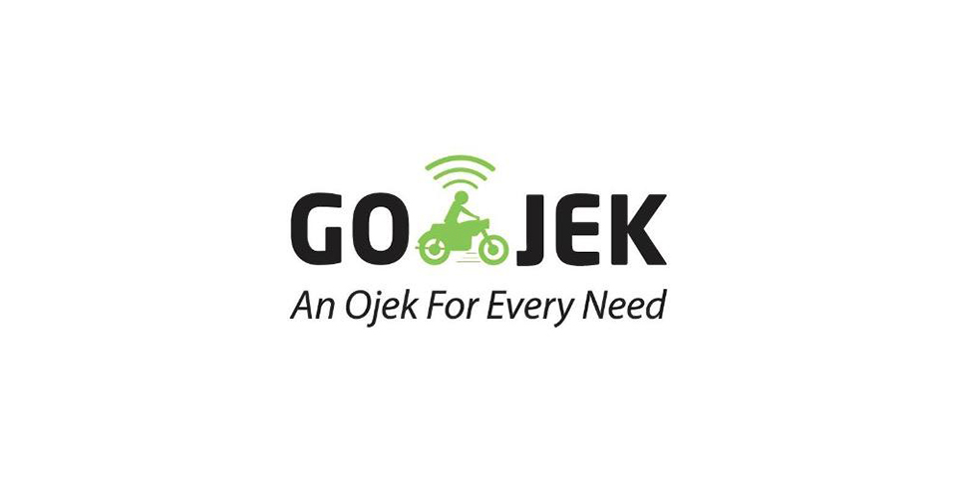

## About GO-VIET

GO-VIET is proud to be a strategic partner of GO-JEK, providing multi-service applications with four-wheel and two-wheel drive transportation solutions, ordering, delivery and many other services [[2]](https://www.go-viet.vn). Serving the daily needs of Vietnamese users.

With GO-JEK's advanced world technology platform, GO-VIET aims to improve the quality of life for our users and create value for our partners and communities.

Besides to the riding service, goods delivery, shopping, GO-VIET is the solution to help you handle daily needs easily, conveniently and quickly.

GO-VIET cooperates with thousands of driver partners, restaurant partners and other partners in Viet Nam to bring you a comfortable experience on every service. GO-VIET's products are aimed at facilitating users and solving social problems such as employment, income and business development of small and medium enterprises.



# EXISTING IT SERVICE SCOPE

GO-VIET is an application for ride-hailing, online shipping, food delivery, billing and daily services. At the moment, GO-JEK invests more than US $ 500 million in 4 markets in South East Asia including Vietnam, Singapore, Thailand, Philippines. With that amount of money, GO-VIET in Vietnam is the biggest competitor of Grab in Vietnam, when it owns more than 95% of the market ride-hailing technology.

## Current Services

GO-VIET is currently providing a variety of mobile transporting and shipping services including:

* **GO-BIKE**

GO-BIKE is a motorcycle drive technology service of GO-VIET has just launched, application will connect motorbike drivers with customer using GO-VIET application to solve the traveling needs of customer as well as increase additional income for the driver.

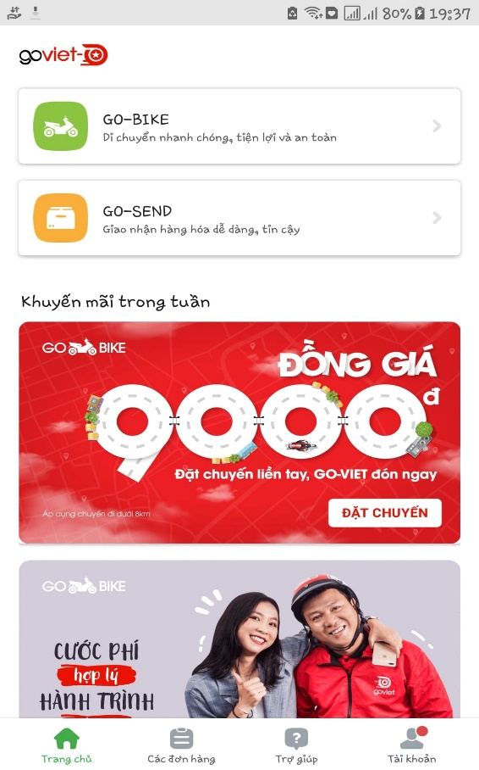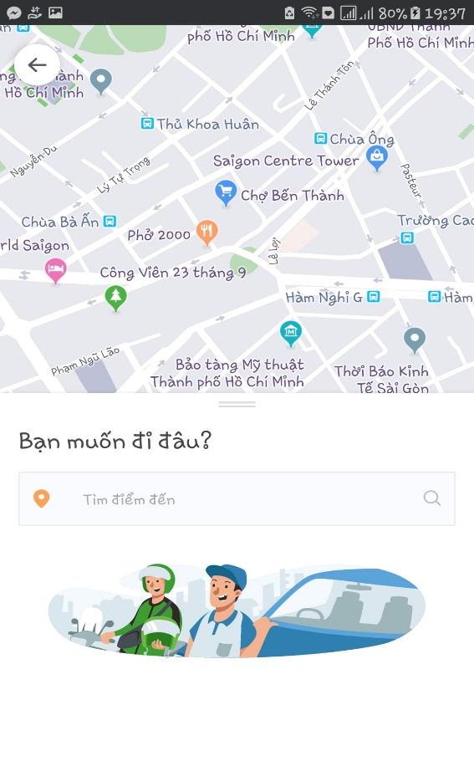

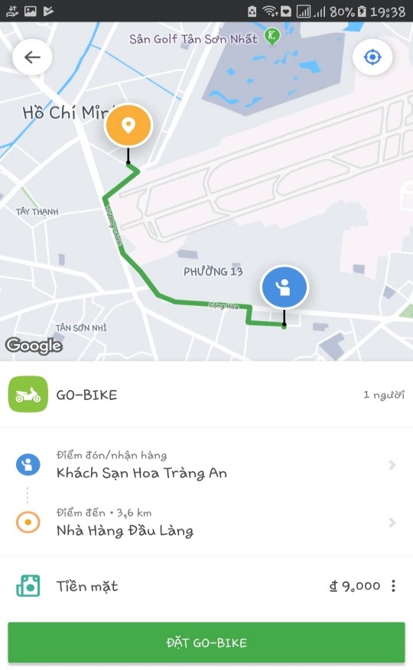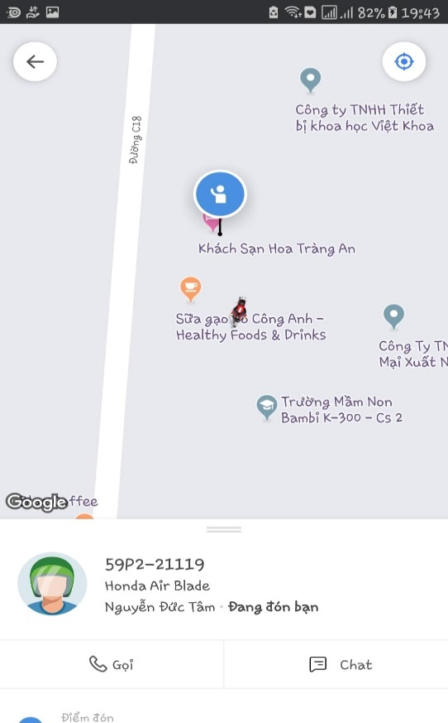

* **GO-SEND**

GO-SEND is a GO-VIET motorbike delivery service for customer who wish to book the delivery. You can easily deliver letters, goods, gifts, products safely, quickly and economically. Commodities will be delivered by GO-BIKE drivers of GO-VIET to increase driver's income as well as cost savings for customer.

When using GO-BIKE and GO-SEND, customers don’t have to worry about the distance, price or time because even it’s far or near, day or night, dry or wet, GO-Driver will happy to delivery their customer’s goods to the location. That’s the strong side of GO-VIET which made this company become the 1st competitor of Grab nowadays.

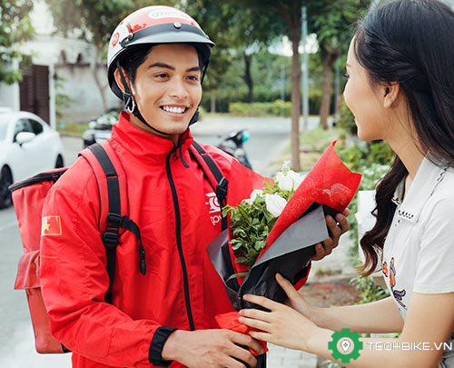

## 8Ps characteristics of both services

To clarify two services above, our team are going to identify 8Ps of both services to understand more about how GO-VIET’s IT Service Strategy are:

In general, it can be seen that the IT Service Strategy of GO-VIET is mainly focus on Delivery Market because hi-tech bike model in Vietnam is the potential market (less competitor: Grab, Uber, Fast Go). Firstly, GO-VIET has implement hi-tech bike framework for the market share war. Secondly, they are going to increase the marketing and promotion activities at the same time to take the market share. Finally, they will expand some services based on hi-tech bike from GO-JEK with small and medium size to consider that services can adapt to Vietnam’s market or not (GO-CLEAN).

# GO-CLEAN

As GO-VIET expanding its business, GO-CLEAN will be the next service in Vietnam. GO-CLEAN, with the moto “**CLEANING YOUR HOME IS NO LONGER A CHORE**”, will give customers the most professional cleaning service at anytime and anywhere.

## About GO-CLEAN

GO-CLEAN is an app-based professional cleaning service which available in many large Indonesian cities[[3]](https://www.go-jek.com/go-clean/).

GO-CLEAN’s customers will choose from the app with 4 main categories are **Building types**, **Main services**, **Amount of cleaners**, **Time/date and Address**. In addition to those main tasks, customers also can choose additional services too. This is the current list of each category that this service provides.

* **Building types:**
* Houses
* Lodging Rooms
* Apartments
* Shops
* **Main Services:**
* Sweeping
* Mopping
* Dusting
* Bathroom Cleaning
* Room Cleaning
* **Additional Services:**
* Ironing and Folding
* Cabinet Cleaning
* Refrigerator Cleaning
* Washing up
* Kitchen Cleaning
* Stove Cleaning

Below are the steps of ordering GO-CLEAN services on application and it will be converted in Vietnamese version.

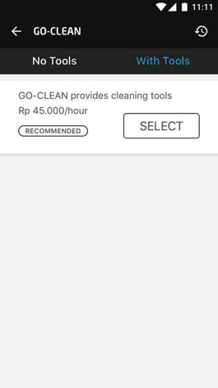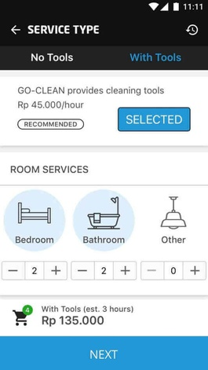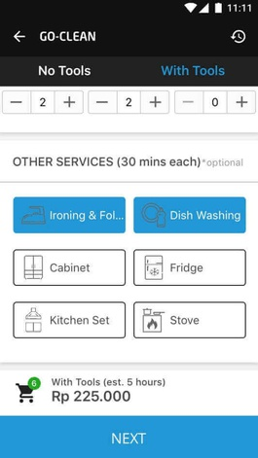

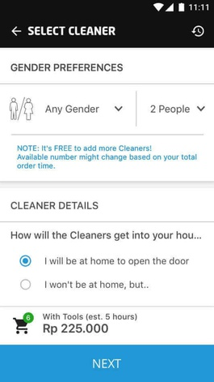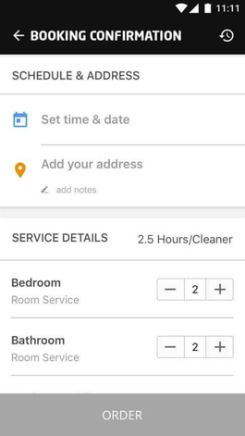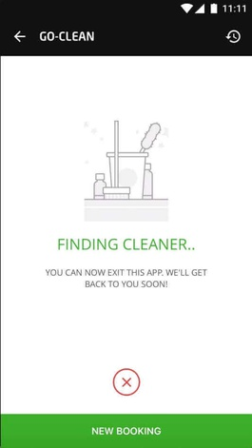

In the side of cleaners, GO-VIET will provide them with necessary tools and uniform to operate services and proper training to perform cleaning like conversation with customers or standards of cleaning. In additional to that, GO-VIET also provide a ranking system to promote cleaners with higher rating.

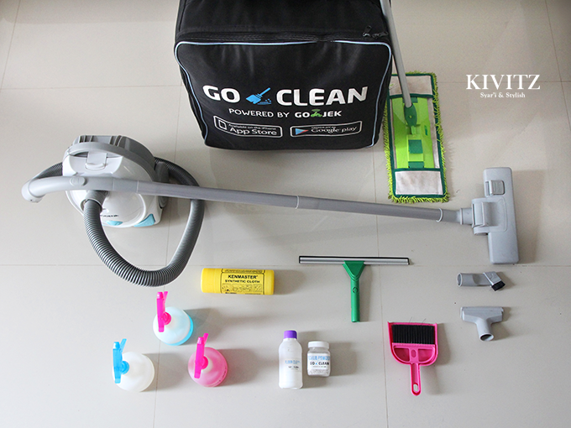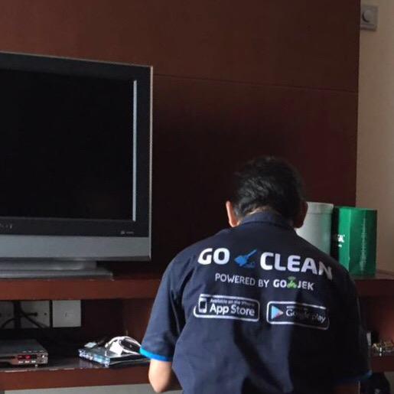

GO-CLEAN tools box GO-CLEAN uniforms

## Why GO-CLEAN is the best Cleaning Service in Indonesia

They have more than 700 skillful and friendly employees in cleaning field. Moreover, all of them are selected carefully and received a special training course before becoming our official staffs.

They co-operate with the best provider in cleaning equipment in order to provide customers our professional service.

GO-CLEAN is active 24/7. That is mean, you can call us any time you want. In addition, we work with many elite partners, so customers do not worry our service.

They know there are many families have limit budget. However, they still want to use our service. That is why we create a list of option services which can help customers choose what they really need.

* **Customer responses:**

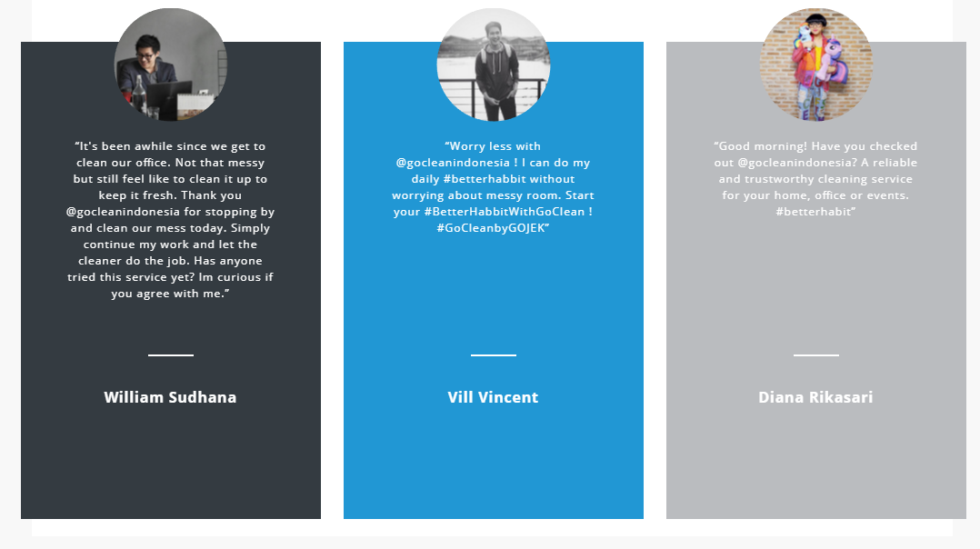

* **Professional Partners:**

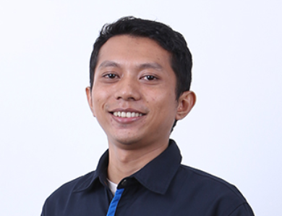

* An ex-supervisor of GO-LIFE.
* He wants to earn more money for his family. However, a full-time job will waste too much time.
* He retired from his previous job and focus on GO-CLEAN.
* He creates a connection between him and other people from various jobs.
* He can help his wife establish a food online base on his connection

**Pak Sugeng**

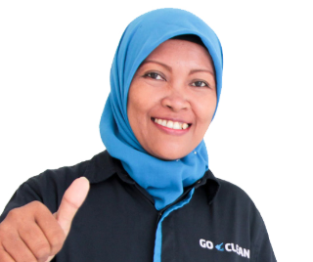

* She is a five star ranking cleaner.
* She is a mother who truly inspire us.
* She works as a GO-JEK driver and GO-CLEAN cleaner.
* She can save enough money for her eldest child to study at the University of Indonesia.

**Nuridah**

# DEFINE KEY SERVICE ELEMENT OF GO-CLEAN

## Identify Market in Vietnam for GO-CLEAN

According to the annual report and financial report in 2017, many statistics show that:

* Total numbers of household in HN and HCM city about: 3.5 million.
* About 15% household need to rent a domestic helper or housekeeper.
* Average salary of a housekeeper per hour: 40,000-50,000 VND.
* Average salary of a helper per month: 4.5 mil VND.
* In HCM city, nearly 10000 housekeepers only adapt to 30% of the market and the needs will continue increase in the future.

Those elements above contribute to create a market for building applications to hire a domestic helper that is estimated more than 1,400 billion VND-a huge mark. Thus, many housekeeper suppliers participate in this area and divide into 3 types:

* **Traditional type**: includes recruiting, training and providing workers.
* **Half traditional type**: add supporting of hi-tech for transaction, resolve and estimate quality of services (Go-clean service)
* **Only hi-tech:** link between provider and customer not provide worker directly.

## Analyze 5 key elements of Go-Clean Service

* **Resources:**
* Include all of manpower of Go-Clean service, experience knowledge and physical resource as tools for cleaning house, Go-clean tools box...
* Physical network, smartphone, the servers, uniforms, bikes, SAN...
* **Provider:**
* As GO-JEK, GO-VIET will expand CLEAN service to provide better application and skillful housekeeper to their customer.
* **Consumer:**
* Employee(cleaners): most of house helpers are older woman who have free time and want to become a house helper. Most of them lack experience in cleaning household and need money. Thus, they need a training course before provide workers to customer.
* Customer: who lack time to take care their house and do chores so they need cleaners.
* **Benefit:**
* Service provider: Go-Clean will gain benefit from 15-20% per contract between customer and employee. By satisfy the need of customer GO-CLEAN improve service with skillful helpers, provide ranking system, attract more customer to increase revenue and prestige.
* Customer: Save their time from doing chores. Have more time and healthy to enjoy their life.
* Employee: Earn more money (5.5-6 mil/month) by using their free time more effective.
* **Time**
* Typically, customer take 5-6 days to contact with employee in real life by intermediate organizations. But, with Go-Clean, customer only take a half day to meet employee directly at their home and have a week trial period before signing a contract.

# APPLY DART MODEL TO EXPLAIN THE PROCESS OF CO-CREATION

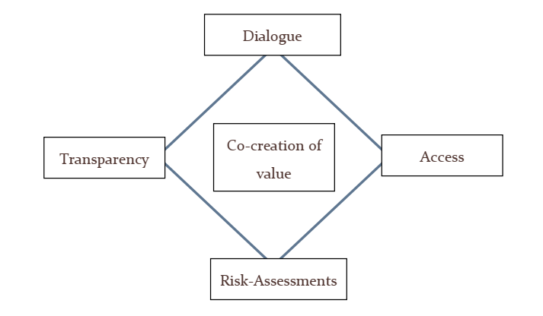

## Dialogue

From the meaning of Dialogue is to shared learning and communication between two equal problem solvers. We propose to create communication platforms that are popular in Vietnam:

* Facebook –via Facebook fanpage and Facebook group.
* Youtube channel.
* Feedback form.
* Surveys.
* Notifications of apps/SMS/email.
* Emergency call center.

Hence Facebook is the most used social network in Vietnam, GO-VIET should take advantages two of its features: fanpage and group. Fanpage is used to give out exclusive news. Group is for collecting opinions from users to company and vice versa. We suggest that we should use a join group for both consumers and partners.

Meanwhile Facebook video functions is still lackluster, Youtube channel is the main way for video solution.

Feedback and survey are still an available option for getting opinions from customers, although they serve different objectives.

Push notification through apps, SMS and email is also a solution for give news or personal informs for users.

Emergency call center is a must in all service, it not only for helping customers with emergency problems but also give solutions from data collected from critical case.

## Access

Customers and candidates can access to our service via website or application in both PCs and mobile devices.

**Consumers:**

* + They can access in both application and website if they have account (using Facebook account or creating go-life account).
  + They can choose suitable service in option list area.
  + Consumers can judge Go-Clean cleaner.
  + Consumers can see partner information, feedbacks and ranking data.
  + Consumers can see all information of service include fee before deciding.

**Partners:**

* Partners can work with Go-Clean if they have accounts and verify by Go-Clean admin.
  + Partners can use company equipment: cleaning tools box, uniforms...
  + They can see their information customers…

## Risk and Reward Assessment

During the process of operating Go-Clean service, our team are going to define many cases of risk and recovery methods to guarantee all rights of customer:

|  |  |  |  |  |
| --- | --- | --- | --- | --- |
| Category | Examples of Risk | Risk effective | Risk Probability | Risk Mitigation Methods |
| Technology | Loss of database server | High | Low | -Backup file on server weekly.  -Recover data |
| Application has stopped working or errors. | High | Low | -Call hotline to take helps immediately. |
| Security | Lost account password | Medium | Medium | -Send email or SMS to service to reset password |
| Policy & Legal | -Leak information of customer | High | Low | -Compensate for client base on level of damaged |
| -Payment process take more money than usual | High | Low | -Contact the service to refund the money |
| Personal& Infrastructure | -The helper steal assets from customer | High | Low | -Each employee must sign the constraint about ethical job.  -Compensate for client base on level of value of stolen items. |
| -Fraud and sale out the asset of company | Medium | Low | -Employee will be fired and arrested depend on level of loss. |
| -Broken cleaning tools. | Low | Low | -Employee must assure conditions of cleaning tools are good before doing.  -Compensate for company if broken tools. |
| -Employee do personal contract with customer. Do not pay for Go-Clean | High | Low | -Employee must sign a contract that obligate employee compensates for break the contract. |
| -Employee break the contract with clients. | High | Low | -Other helper will be assigned to help client with company’s apology and compensation gifts. |

Risk Assessment of GO-CLEAN Service

**The main benefits of GO-CLEAN Service:**

According to frame work of Go-Clean Service at Indonesia. Based on the market and the needs in Vietnam[[4]](http://ndh.vn/app-giup-viec-nha-thi-truong-trieu-do-20161201071757844p145c151.news), we suggested that GO-CLEAN should decide to operate 3 type of cleaning services (all data are estimated by research):

* Help by time with two options (about 3,100,00 VND/month):
* 3.5 hours / session x 12 sessions / month.
* 3.5 hours / session x 24 sessions / month.
* Advantages:
* No cost for accommodation, travel, Tet bonus for maids. Savings on average 3 million / month.
* Does not affect family life.
* The baby is not affected by the voice, the habit of the maid.
* Not dependent on a single maid.
* Help from the morning to evening with two options:
* VND 5,800,000 / month if Contract > 3 months.
* VND 6,000,000 / month if Contract ≤ 3 months.
* Advantages:
* Assist in the time frame required by customers.
* The maid provides full of records, good personalities.
* Recruited by Go-Clean, management, training.
* Does not affect to family life.
* Save time and money.
* Additional Cleaning Services: Shops, Building, Industrial hygiene after construction…
* Advantages:
* Workers are trained cleaning skills according to foreign standards.
* Use genuine imported cleaning chemicals, no health effects, no dame to furniture.
* Warranty of all services. Insurance in case of dame to furniture or assets.

## Transparency

With clients, we suggested that GO-CLEAN should always provide trusted information about helpers. Each client joining in our system can review the feedbacks and profile of any helper. Feedback system always provide trusted ranking from client not from bot.

With employee, GO-CLEAN should provide professional cleaning tools that help their work smoothly. Employee also receive benefits without monthly salary such as: bonus base on feedback ranking system, travel…

Each interaction process always assures the present of three sides: sign contract, rules. The constraints of employee and company must be clear information to client and reversed.

Every contract is always legal and ensure all rights of customer and partners.

# JUSTIFY CO-CREATION PROCESS

Different from manufacturing products, service is not end after its release even it is a completed product. It will need practices to improve even though R&D departments carefully did their parts. These works need the help of two side of the business, and called “*Co-creation*”.

Below are the processes that our team would like to design for GO-CLEAN:

* **Feedback system**:

Firstly, we would like to add into Go-clean service the feedback system for users to give us what they think about the service itself or just a simple rating. Why we should apply this into our new service? By doing this, we can:

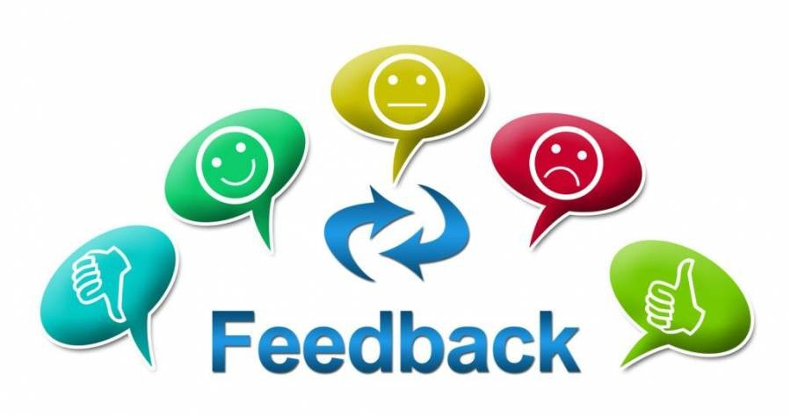

* + Improve products and services
  + Measure customer satisfaction
  + Create the best customer experience
  + Creating reliable source for information to other consumers.
  + Collect data that helps taking business decisions.
* **Tinkering**:

The second co-creative practice that we would like to apply into our new service is the filter of searching engine. Why we should apply this into our new service? Some of our partners has reported that there’s no or just a few users hired them for work, while other partners in the same area was hired more and earned more income. Realize that there’s something wrong with the search engine and the ranking function, we would deploy the feedback function on the partner app in order to receive their complains about the schedule of their work, then compare it with other partners in the same area to reorganize the ranking of partner when the users searching for cleaner in the area, ensure that all of our partners are shown on search result.

So company and partners will join hand to do a co-creation which is “**Tinkering the matching algorithm**”.

After deploy the re-work of the searching engine to user application, the better result of searching is shown. When user turn on their location and use the search function to find the cleaner, the result will show the cleaner, not by the ranking or the location of that cleaner is near the user but the top result is for the partner who is not been hired recently. If the cleaners of that location are all hired, the top result will show the same function for the surroundings. We also deploy the discount code on those partner who has not been hired for too long, which will encourage the users to book them.

On the side of the partner application, when using the new function for searching, better result is shown according to our counting variables, less report received about the schedule matter. In case there’s a report about that, we will consider about giving discount code for them.

* **Collaboration**:

From the above situation, the partners expect that the company have a public policy about the core of problems – which can be elaborate about time of works, expecting amount of a task, a proper amount for jobs per days and etc. With this co-creation process that collaborate to create a good policy, both sides gain lots of benefits.

# DEMONSTRATE A CO-CREATIVES PRATICE

First of all, the basic problem of our GO-CLEAN service is when a group of our partners complain that there’s just a few or even no users hired them for cleaning, while other partners in the same local area was hired more often and earned more profits for themselves. After considering all aspects of the problem, we end up with the best method that we can demonstrate: Improve the current algorithms of searching engine.

By using this method, we need to work and co-operate with 4 stakeholders:

* **Go-Viet company and Go-clean service staffs**: understand and become skilled in using the new algorithms into current searching engine to perform effectively and professionally. We don’t need to understand the algorithms but must have abilities in manipulating it in the infrastructure that they have.
* **Algorithms supplier experts**: Go-Viet company has to contact the suitable Algorithms supplier to co-operate and create new algorithms that can bring effective result in changing the old one to the new great one.
* **Cleaning Partners:** this is the most important factor that express the result of new algorithms by collecting all the feedback from themselves using the feedback system. After that, they bring the result of feedback system report for the service team.
* **Users**: this stakeholder is the second-most important factor that continue to use Go-send application normally after the change, but keep rating during the service running for the company to collect the data.



# CO-CREATION FRAMEWORK

As the business expand, the more co-creation processes will be created. The follow is predicted processes of both side of customers: partners and consumers.

**PARTNERS(Cleaners)**

|  |  |  |  |  |
| --- | --- | --- | --- | --- |
| **Customer processes** | **Goals in life**   * Full time jobs * Part time jobs * Social interaction * Works have Insurance | **Training plans**   * Learn about how to communicate with consumers * Learn about cleaning process * Learn about problem solving when servicing * Obtains tools for servicing | **Tinker matching systems**   * Balance the schedule for partners. * Give equality for all users * Improve distant between partners and work places * Full time/Part time option | **Co-create policy**   * Working contract * Working insurance * Keep partners benefits |
| **Encounters** | * Advertisement | * Face-to-face classrooms. * Training documents. * Direct mails * Tests * Feedback forms | * Feedback forms * Face-to-face meeting * Petition forms * Data collected from apps | * Feedback forms * Face-to-face meeting |
| **Supplier processes** | **Supports of GO_VIET**   * Support the missions of partners that want to earn livings through house works. * Improving brand recognition * Attractive marketing communication | **Training support**   * Trains partners about communication * Trains partners about Term of Service, policies * Trains about cleaning process and self-validate the result * Trains about using how to use tools * Trains about solving typical problems | **Improve matching systems**   * Analyze data collected * Tinker the matching system. | **Policy support**   * Follow the policy * Help to improve policy |

**COSTUMERS**

|  |  |  |  |  |
| --- | --- | --- | --- | --- |
| **Customer processes** | **Goals in life**   * Need some house works helpers that trustworthy at a reasonable price * Save time | **Features**   * Pay by cash or credit cards * Good feedbacks system * Good rating systems * Good range of options for selected * See details of payments * Specific schedule * Security * Services be done right | **Improvement**   * Expands more payments methods * Keep the quality of service stable * Payments plan * Loyal customers plan | **Co-create policy**   * Users contract * Service insurance * Term of services |
| **Encounters** | * Advertisement | * Face-to-face * Direct mails * Feedback forms * Market research | * Feedback forms * Face-to-face meeting * Petition forms * Data collected from apps | * Feedback forms * Face-to-face meeting |
| **Supplier processes** | **Supports of GO_VIET**   * Support the missions of consumers that want to solve house works problems. * Improving brand recognition * Attractive marketing communication | **Training support**   * Provide the consumer’s needs in the app * Track working process to ensure service delivery the right way * Solve the data collected | **Improve matching systems**   * Analyze data collected * Counteract with the requirements from customers | **Policy support**   * Follow the policy * Help to improve policy |

# THE RECOMMEND IMPLEMENTATION APPROACH



As those elements that we have analyzed above, GO-CLEAN service is predicted as a change for GO-VIET expand the market in Vietnam. However, they need an implementation plant to develop this service to ensure that this service will probably work as well as in Indonesia. That will depend on many characteristics of market, especially the Vietnam’s culture. Our group has suggested that GO-VIET should implement GO-CLEAN as diagram below:

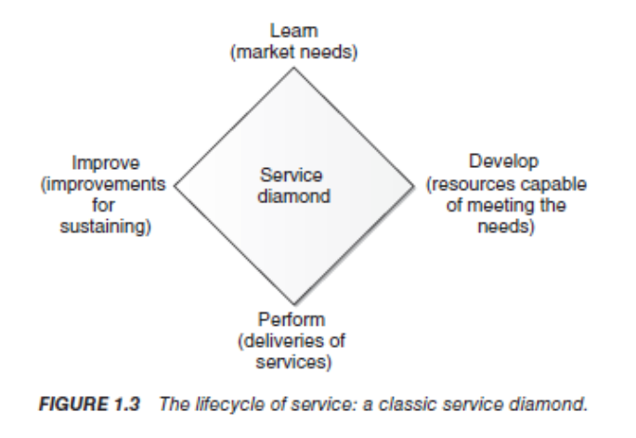

## Learn

Before implement a new service as Go-Clean, Go-Viet must identify their growth status and the needs of market. That mean they need a R&D team who can research and develop Go-Clean service:

* Human power: about 4-5 persons.
* Time estimated: ≤ 1 months.
* Physical resources.

After that, the team is going to make a plan with the list of current resources that support for Go-Clean Service. To make a plan for implementation new service.

## Develop

To develop Go-Clean as completed application, the team need:

* 2-3 months for 1 new function and demo as Tinkering or feedback system.
* Document all feedbacks and idea from client(Go-Viet).
* Manage human resources, risks, time.
* Training plan.
* Budget (estimated about 5000-8000 USD)

For develop cleaning service:

* Finding partners who can provide cleaners or tools.
* Physical resources: uniforms.
* Marketing plan.

## Perform

To perform Go-Clean service, the team should:

* Recruit the cleaners and develop training plan for them.
* Operate service as small size firstly.
* Provide cleaners direct to customer house.
* Then collect feedback and reflect on ranking system.
* Time estimated: 6-12 months.

## Improve

For improvement Go-Clean:

* Improve IT infrastructure: system, application performance.
* Improve the quality of service, listen to customer.
* Improve tools and skill of cleaners.

# REFERENCES

1. [“ About GO-JEK”](https://www.go-jek.com/about/). Accessed in 12/09/2018.
2. [“About GO-VIET”](https://www.go-viet.vn). Accessed in 12/09/2018.
3. [“About GO-CLEAN”](https://www.go-jek.com/go-clean/). Accessed in 20/09/2018.
4. [“The Market of Cleaning House in Vietnam”](http://ndh.vn/app-giup-viec-nha-thi-truong-trieu-do-20161201071757844p145c151.news). Lan Anh from Nhipcaudautu.vn. Accessed in 20/09/2018.